Welcome to Durham Region Law Association Membership for 2019
The Durham Region Law Association and Library's primary mission is to support, in both a print and digital capacity, the citation research, reference and educational needs of the Lawyers. In addition, as the only research level law library in Durham Region, it is an important community resource hub for professional and social networking. The Law Library and Association strives to serve the legal information needs of the entire legal community and the practicing bar, as well to promote the most up to date sources and services available.
As per the DRLA’s Bylaws, there are five classes of membership available: Honourary Member; Life time Member; Ordinary Member; New (Call) Lawyer Member, and Articling Students.
Thank you for your continued and new membership; please follow the instructions below to complete
your registration/renewal for 2019.

- Fill out attached application, one per member of your firm.
- Send payment:
- Cheque to Durham Region Law Association and send to Jennie Clarke, Librarian, 150 Bond Street East, Oshawa, ON, L1K 0A2.
- E-Transfer to drlatransfers@gmail.com (See package for the E-transfer form attached)
- Arrange an appointment with Jennie to receive an ACCESS CARD (This process takes up to 24 hours to be approved and printed)

- Mail and Email Applications. DO NOT FAX.
On December 31st, 2018, members who have not paid for their membership in full will have their access cards deactivated.

On behalf of the Board of Directors we thank you for your continued support in making Durham Region Law Association a wonderful, vibrant and informed community.

Best,

Jennie Clarke Michelle Brown -VP
Law Librarian Membership/Mentorship Chair

MEMBERSHIP APPLICATION FORM 2019 (January to December Calendar Year)
Contact Information:
Name: _______________________________________________Year of Call to the Bar: _____________________
Firm: ______________________________________ Telephone____________________________ ext._________
Address: ____________________________________ Email: ____________________________________________
City________________________________________ Fax: _____________________________________________
Postal Code: __________________________________ Website: __________________________________________
FEE: Ordinary Members $125.00 New Calls & Articling Students $50.00
(Cheque payable to Durham Region Law Association) E-TRANSFER

CASL: I consent to receiving DRLA emails regarding CPD, social events, court news, member info, FOLA and DRLA news.

Law Clerk EMAIL: Please add my law clerk to the email distribution _____________________________________
WEBSITE/PDF DIRECTORY: I do not want to be listed on the DRLA website at this time. I I do want to be listed on the DRLA Website and Directory.

If you have consented to a listing on the DRLA website (above), please complete the following information.
Area of Practice (please select up to four (4) preferred areas of practice form the list below.

 | Aboriginal |  | Corporate/Commercial |  | Intellectual Property
 | Administrative Law |  | Criminal |  | Labour/Employment Law
 | ADR/Mediation Services |  | Environmental |  | Medical Malpractice
 | Bankruptcy/Insolvency/Receivership |  | Expropriation |  | Municipal
 | Business Law |  | Estate Litigation |  | Personal Injury Law
 | Civil Litigation |  | Elder |  | Professional Negligence
 | Collaborative Family Law |  | Family/Matrimonial |  | Real Estate
 | Commercial Leasing Law |  | Human Rights |  | Small Claims
 | Commercial Litigation |  | Immigration |  | Taxes
 | Construction Law |  | Insurance Litigation Law |  | Wills & Estates
Second Language: ___________________________/___________________________
Dated this ________ day of______________, 2018_________________________________________________

(Applicant for Membership)

NOTE: YOU MUST PAY YOUR MEMBERSHIP IN FULL IN ORDER TO RECEIVE YOUR ACCESS CARD. IF MEMBERSHIP IS NOT PAID ANNUALLY YOUR ACCESS CARD WILL BE DEACTIVATED.
At the Durham Region Law Association, the privacy of your personal information has always been, and always will be, of paramount importance to us. In this context, as you may be aware, there has been a recent development in the area of personal information privacy. Canada’s Federal Personal Information Protection and Electronic Documents Act (PIPEDA) became applicable within each province and territory as of January 1, 2004. We are making every effort to be fully compliant with PIPEDA. By doing so, it is our commitment to the protection of your personal information. We will obtain personal information only as necessary for purposes relevant to serving you. We will not release, retain or use that information for other purposes. We have appropriate security measures in place to protect your personal information which you are encouraged to inquire about. Please contact the library if you wish to have further information. By signing, dating and returning this form to the Durham Region Law Association, you are indicating your consent to using this information for the purposes intended by the Durham Region Law Association, which are membership lists and the website.

DRLA EMAIL TRANSFERS

Steps to follow to ensure a smooth transfer
Name: _______________________________________________________
Firm: _______________________________________________________
Email: _______________________________________________________
Transfer Question: ____________________________________________
Transfer Answer: ______________________________________________
****Once our librarian has this information it will be used for all your company’s future transactions unless otherwise instructed.

Please send your funds to drlatransfers@gmail.com

ADVANTAGES OF MEMBERSHIP 2019
LIBRARY BENEFITS | MEMBERSHIP BENEFITS
- WI FI throughout the library and lounge area  - 8 workstations and 2 laptops  - Print Collection of over 1000 titles  - Digital Collection of legal databases: Access to Lexis Nexis Quick law, Hein Online, Wrongful Dismissal, O’Brien’s  - Circulation Privileges  - Document Delivery and Interlibrary Loan  - Digital Collection of e-resource books including all areas of practice (available on our laptop hardware – please sign laptop out)  - Microsoft Office – Word, Excel and PowerPoint  - Divorcemate – available on 2 workstations (FORMS included)  - Self-Serve Photocopier – available printing, scanning and USB saving  - Headphones for CD-ROM and DVD purposes  - Assistance with research and citation searching  - Ready Reference Services  - Self-Serve – Cerlax Binding  - Fax Machine (Local and Long Distance)  - Email notification of current events in the profession and legal community  - Twitter and Facebook Presentations | - 24-hour pass card access to the courthouse, law library and robing rooms – with paid membership an access card will be issued to you.  - Mentorship Program  - Case law can be sent by email or fax to your office, at no cost  - New membership for recent call (under five years) will receive a one-time complimentary Association dinner at our AGM  - Recent calls (under five years) pay half the regular membership costs  - Networking opportunities through DRLA events and website  - Discounted rates of continuing legal education programs, sponsored by the Law Society of Upper Canada, the Advocate’s’ Society and the Ontario Bar Association, at a significantly discounted cost for paid up DRLA members  - Opportunity to participate in social events, including golf tournament, annual general meeting of the Durham Region Law Association as well as other special events  - Inclusion in the online membership directory on the Durham Region Law Association web site (www.durhamregionlawassociation.com)  - Use of the video conferencing facilities in the courthouse for all members of the bar regardless of area of practice  - DURLAW newsletter and monthly bulletin  - Insurance Benefits

Durham Region Law Association 2019 ~ Survey

How would you like to participate in your Law Association? Please click boxes of interest.

Serve as Director
Participate on DRLA committee
Mentor
Mentee
Attend CPDs put on by DRLA
Contribute to DRLA

Activities and Events:

- What types of social events would be you interested in attending?

- What organizations or charities would you like to see the DRLA sponsor?

- Speakers at events? Who would you like to see?

- CPD Topics of interest.

- Other:

Welcome to Durham Region Law Association Mentor Application Process – MENTOR

Year of Call: ___________
Full Name: ___________________________________________________________
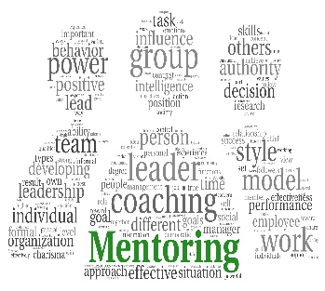
Full Address: _________________________________________________________
_________________________________________________________
E-mail: ______________________________________________________________
Phone Number: ______________________________________________________
Languages Spoken: ___________________________________________________

Mentor Questionnaire
Which areas of law do you currently practice and in what areas do you have experience?

Describe yourself, including information such as extra - curricular interests and affiliations, family, etc., or any other characteristics which you may wish to disclose. Also list past mentoring experience, if any.

What criteria are important for you in the matching process?

What do you hope to gain from the mentoring program?

Welcome to DLRA Mentee Application Process - MENTEE
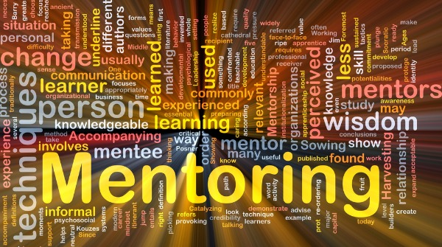
Year of Call: ________________________________________________
Full Name: ________________________________________________
Full Address: ________________________________________________
_________________________________________________________________
E-mail: ___________________________________________________________
Phone Number: ____________________________________________________
Languages Spoken: _________________________________________________

Mentee Questionnaire
Which areas of law do you currently practice or wish to practice?

Describe yourself, including information such as extra - curricular interests and affiliations, jobs worked prior to legal studies, family, etc. or any other characteristics which you may wish to disclose.

What criteria are important for you in the matching process?

What do you hope to gain from the mentoring program?

